**INSTALLATIONS & SETUP**

Before installation my system had:

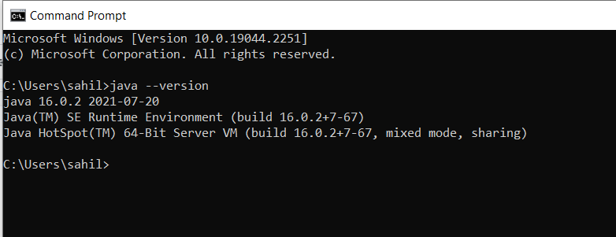

**Link followed:** [How to download and install Java Jdk 1.8 on windows 10 |By Makhan AutomationHub |](https://youtu.be/4TJYD30FDVw)

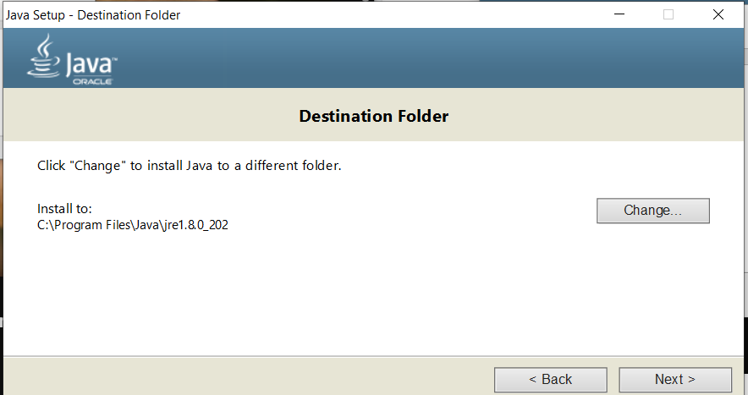

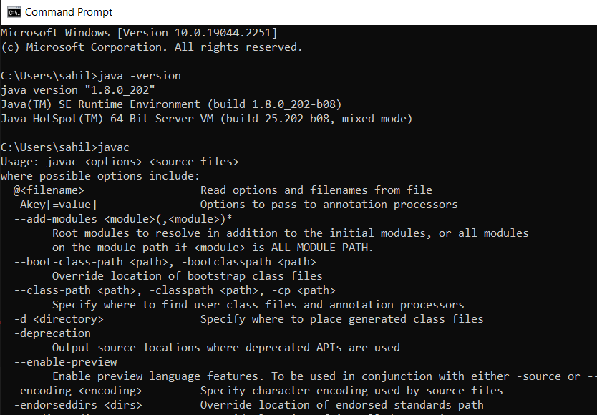

**ECLIPSE FOR EE JAVA DEVLOPERS(Enterprise edition only has server option)**

[**https://www.eclipse.org/downloads/packages/release/kepler/sr2/eclipse-ide-java-ee-developers**](https://www.eclipse.org/downloads/packages/release/kepler/sr2/eclipse-ide-java-ee-developers)

[**https://archive.apache.org/dist/tomcat/tomcat-7/v7.0.47/bin/**](https://archive.apache.org/dist/tomcat/tomcat-7/v7.0.47/bin/)

**APACHE TOMCAT**

[Install and Configure Apache Tomcat Web Server in Eclipse IDE](https://www.youtube.com/watch?v=kLgquZ2FiuQ&ab_channel=ProgrammingKnowledge)

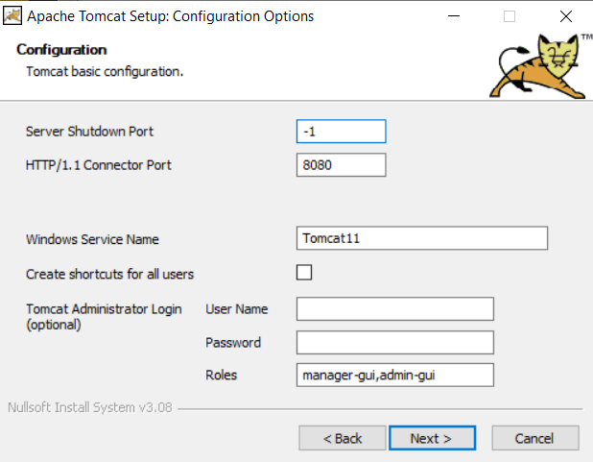

**Apache tomcat configured in eclipse ide**

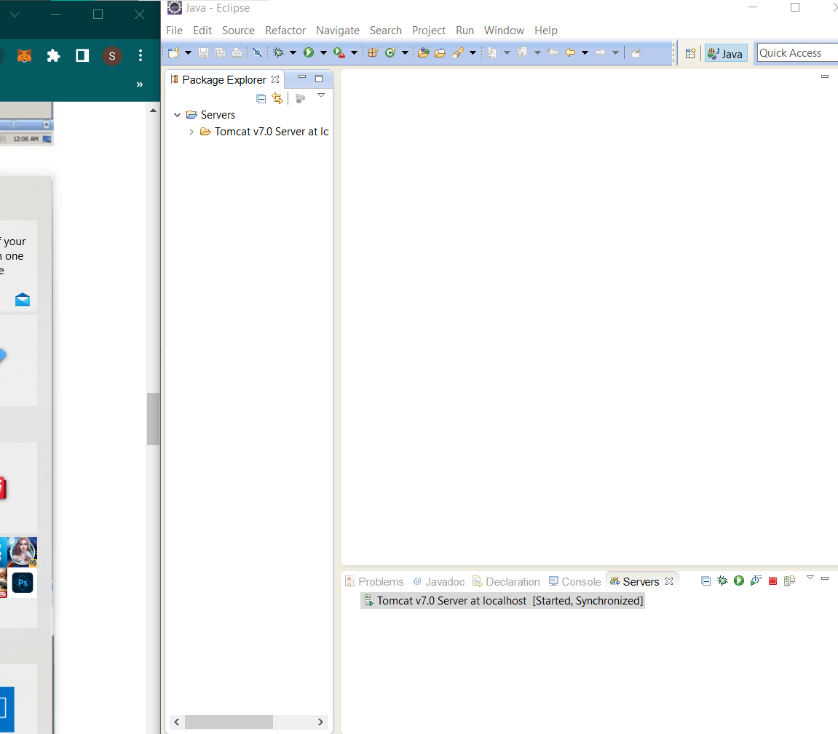

**SQL SERVER MANAGEMENT STUDIO (SSMS)**

[How to Install Microsoft SQL Server 2019 & SSMS on Windows 10/11 [ 2022 Update ] Complete guide](https://youtu.be/kGdTg-vGs-E)

**Links for downloading:**

1. [**https://www.microsoft.com/en-in/sql-server/sql-server-downloads**](https://www.microsoft.com/en-in/sql-server/sql-server-downloads)
2. [**https://learn.microsoft.com/en-us/sql/ssms/download-sql-server-management-studio-ssms?view=sql-server-ver16#download-ssms**](https://www.microsoft.com/en-in/sql-server/sql-server-downloads)

**SQL SERVER MANAGEMENT STUDIO STARTED**

